Linux Exercise 9-Package management

- At first, update package repositories. Then check the available commands for apt using command help. What commands are used to perform the following tasks with apt:
  - Upgrading installed packages in the system
apt upgrade package_name
  - Removing unused packages from the system
apt autoremove
- Check the information for the package called figlet and answer the following questions:
  - What is the size of the package?
752 kB
  - What is the newest version available for the package?
2.2.5
  - Check the package description → What does the program do?
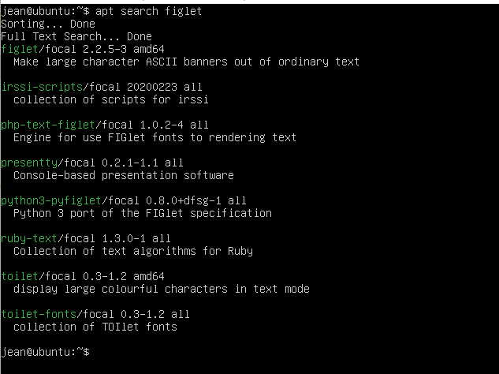

- Install the figlet package and verify it works.
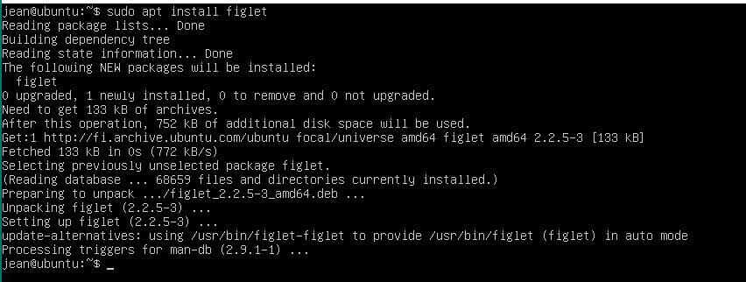
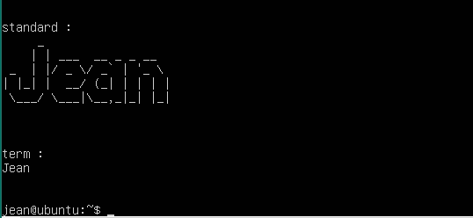
- Remove figlet from the system with all configuration files. Check that program cannot be run after the removal.
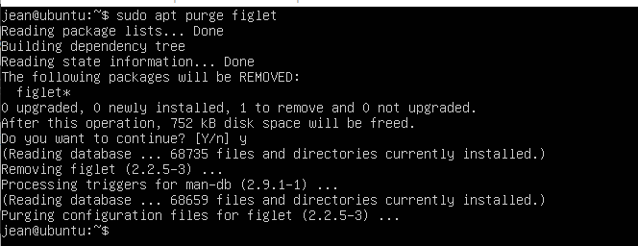
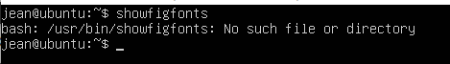

- In this task you must install Python3 by compiling it from the source code. Download the package from the url http://student.labranet.jamk.fi/~hantt/os/Python-3.7.4.tgz.
  - Before the compilation process, install the following packages with apt:
    - libffi-dev
    - zlib1g-dev
  - Find out if you already have newer version of Python3 installed by running command python3. Check the version that is in the output and exit with Ctrl + D.
  - If you have newer version than 3.7.4, find out where this executable is located and replace the existing symbolic link with symbolic link pointing to your Python 3.7.4 version executable.
  - Verify the operation of Python3 by starting the shell with command python3. You should now see the version 3.7.4 at the start of your Python shell.
